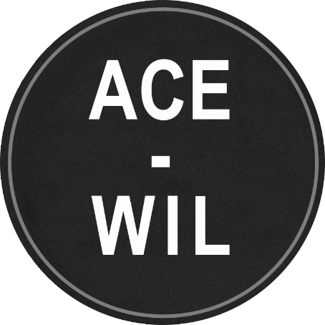
ACE-WIL Board Nomination Information
In accordance with ACE-WIL bylaws, nominations are being requested for the 2023-2025 Board of Directors (two-year terms). The deadline for nominations is Tuesday, February 28, 2023, at 4:30pm PST
Voting, or confirmation by acclamation, will take place electronically at or prior to the virtual Annual General Meeting in May 2023 (date and time TBD).
This year, we have 3 executive positions as well as 5 Director positions up for election:
- President Elect
- Secretary
- Treasurer
- WIL University Director
- Co-op University Director
- WIL Institutes/Colleges Director
- Regional Director, Lower Mainland/Vancouver Island
- Director at Large
Nominations are encouraged from all professional areas and positions. Nominees do not have to be in a management position in their institution to take a leadership role with ACE-WIL. ACE-WIL titles above refer to the board position, not the nominee title.
Nominees will ask for and receive endorsement from their institutions before putting their name forward.
If you have questions on what these roles entail, please reach out to your current board members or plan to attend one of the following info sessions:
- February 14, 2023 (12-12:45pm PDT)
Join Zoom Meeting
https://ubc.zoom.us/j/66767746101?pwd=eG53amVLb3FFZ1FjSXYrRlNESDMwUT09
Meeting ID: 667 6774 6101
Passcode: 020712
- February 21, 2023 (12-12:45pm PDT)
Join Zoom Meeting https://ubc.zoom.us/j/6272850914?pwd=RTBSUEJFcEREcGxITFg1cEEwd1laZz09
Meeting ID: 627 4285 0914
Passcode: 324565
Please submit the Nomination Form below in confidence to president@acewilbc.ca no later than Tuesday, February 28, 2023, by 4:30 pm PST.

ACE-WIL Board Nomination Form

Nominee’s Full Name:
Position and Post-Secondary Institution:
E-mail: Phone:
Brief Biographical Sketch:

Seeking Nomination in which position:
Alternate position(s) if applicable:

*Nominee signature:
(*Written consent of nominee to stand for election)

DEADLINE: Tuesday, February 28, 2023, by 4:30 pm PST
Return to: Anna Jubilo, President, ACE-WIL - president@acewilbc.ca

