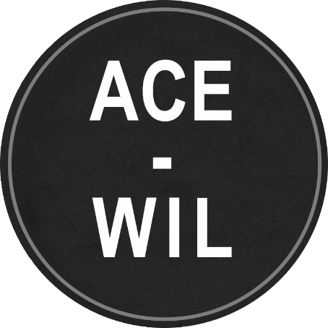
ACE-WIL Board Nomination Information
In accordance with ACE-WIL bylaws, nominations are being requested for the 2024-2026 Board of Directors (two-year terms). The deadline for nominations is Thursday, February 29, 2024, at 4:30pm PST
Voting, or confirmation by acclamation, will take place electronically at or prior to the in-person Annual General Meeting in May 2024 (date and time TBC).
This year, we have 3 executive positions as well as 3 Director positions up for election:
- President-Elect
- Treasurer
- Secretary
- WIL Institutes/Colleges Director
- Co-op Institutes/Colleges Director
- Director-at-Large

Nominations are encouraged from all professional areas and positions. Nominees do not have to be in a management position in their institution to take a leadership role with ACE-WIL. ACE-WIL titles above refer to the board position, not the nominee title.
Nominees will ask for and receive endorsement from their institutions before putting their name forward.
If you have questions on what these roles entail, please reach out to your current board members or plan to attend one of the following info sessions:
- February 14, 2024 (12:15-12:45 pm PDT)
https://sfu.zoom.us/j/8514427789?pwd=cGVxejdsMXhrRjVOTVJtOEZ5c1FlUT09
Meeting ID: 851 442 7789
Password: 043473
- February 22, 2024 (12:15-12:45 pm PDT)
https://sfu.zoom.us/j/8514427789?pwd=cGVxejdsMXhrRjVOTVJtOEZ5c1FlUT09
Meeting ID: 851 442 7789
Password: 043473

Please submit the Nomination Form below in confidence to president@acewilbc.ca no later than Thursday, February 29, 2024, by 4:30 pm PST.

ACE-WIL Board Nomination Form

Nominee’s Full Name:
Position and Post-Secondary Institution:
E-mail: Phone:
Brief Biographical Sketch:

Seeking Nomination in which position:
Alternate position(s) if applicable (encouraged):

*Nominee signature:
(*Written consent of nominee to stand for election)

DEADLINE: Thursday, February 29, 2024, by 4:30 pm PST
Return to: Stephanie Greaves, President, ACE-WIL - president@acewilbc.ca

